**Assignment 24.2**

**Input:**

<https://drive.google.com/file/d/0Bxr27gVaXO5sa0JBamZXdkpYUFk/view?usp=sharing>

**Problem Statement:**

1. **Fetch date and temperature from temperature_data where zip code is greater than 300000 and less than 399999.**

**Solution:**

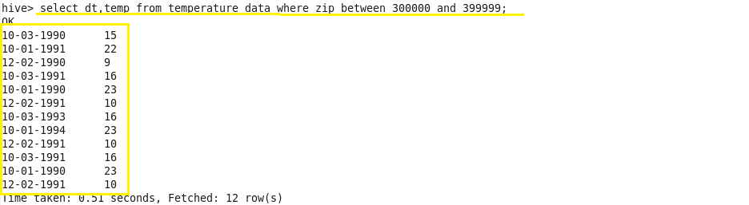

1. **Calculate maximum temperature corresponding to every year from temperature_data table.**

**Solution:**

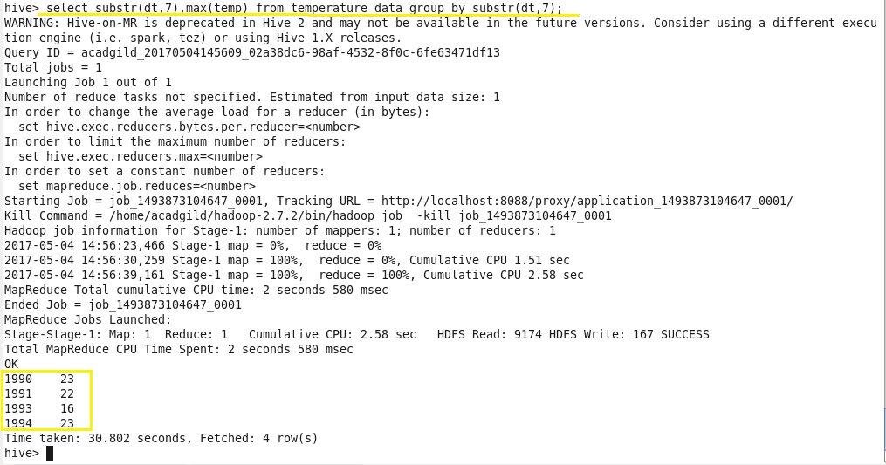

1. **Calculate maximum temperature from temperature_data table corresponding to those years which have at least 2 entries in the table.**

**Solution:**

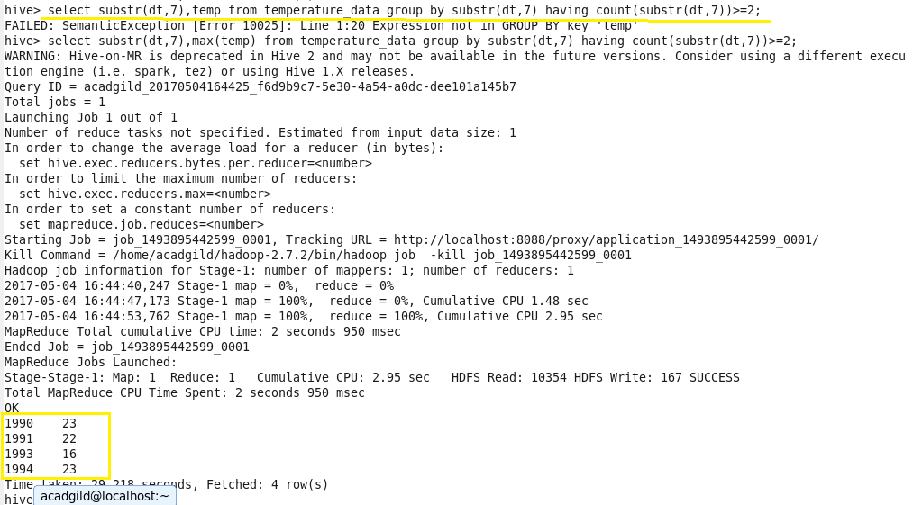

1. **Create a view on the top of last query, name it temperature_data_vw.**

**Solution:**

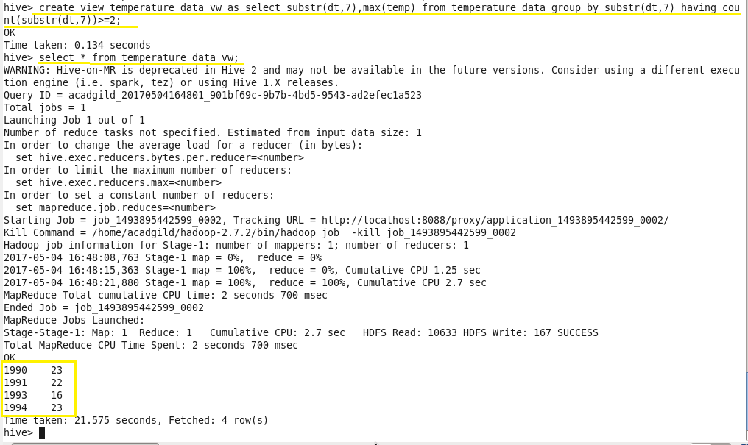

1. **Export contents from temperature_data_vw to a file in local file system, such that each file is '|' delimited.**

**Solution:**

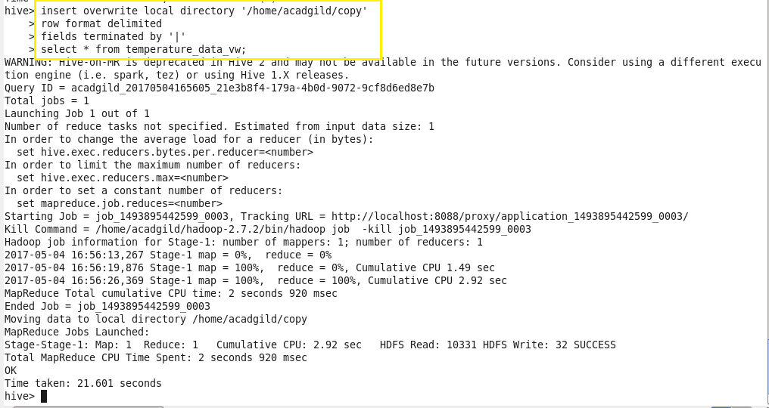

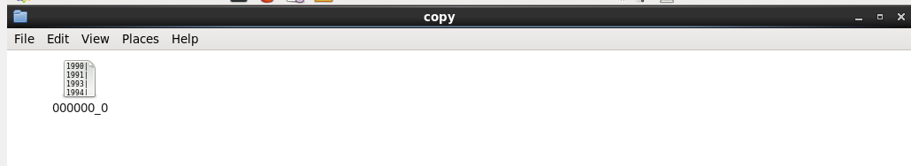

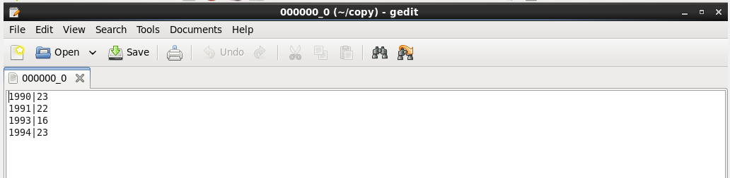

The copy folder is created in given path and the fields are delimited by ‘|’ in the file.